- Devexpress Satellite assemblies copied to « C:\Program Files (x86)\DevExpress 17.2\Components\Bin\Framework\fr »
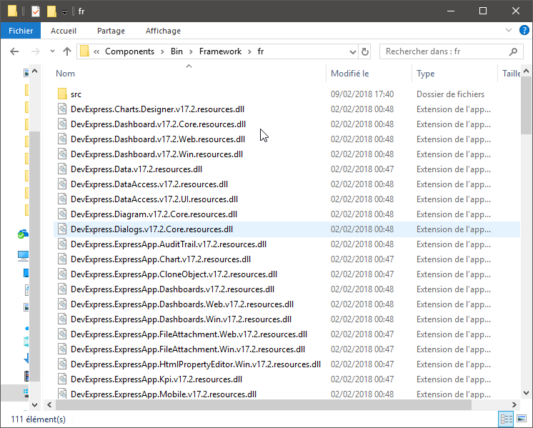

- Main Windows Interface with Arms disabled Automaticaly in French
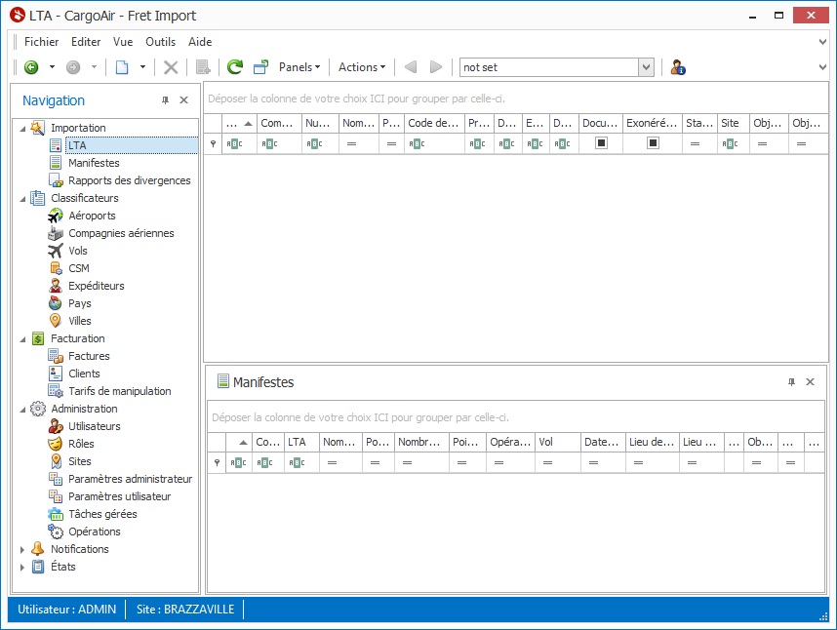

- Main Windows Interface with Arms enabled A party that considers the Devexpress Satellite assemblies gets French but the other remains in English (ArmsMainForm).
